

**Nancledra’s Upper Key stage Two’s Writing Curriculum 2024-24**

Contents:

* Nancledra’s writing approach
* National Curriculum English Programme of Study: Upper Key Stage Two
* Nancledra’s Word, Sentence, Text and Punctuation curriculum and coverage
* Upper Key stage Two’s text and objective overview

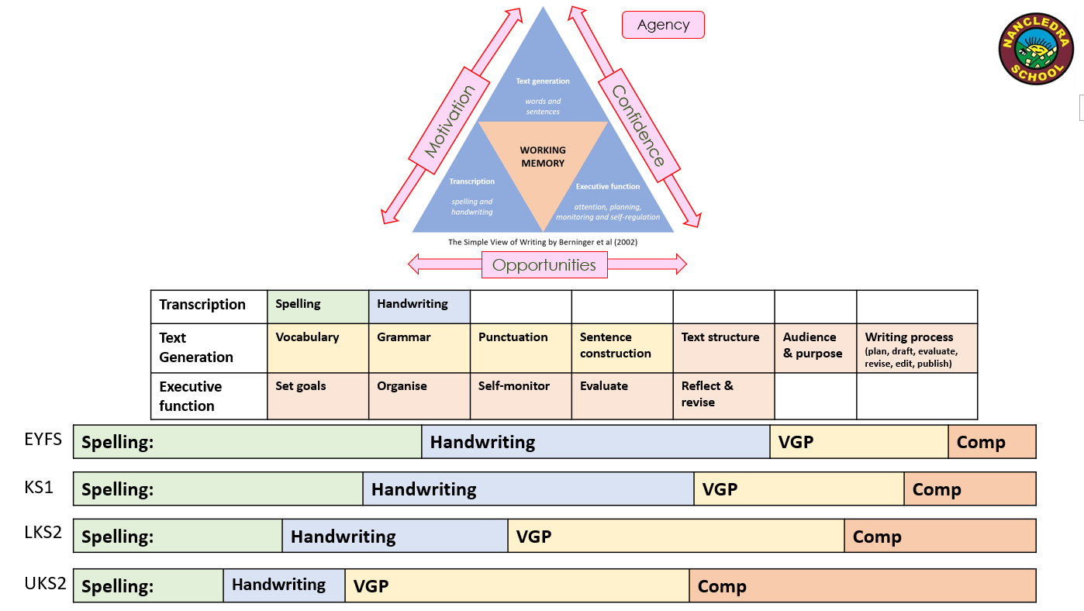Nancledra’s Writing Approach 2024-25

Nancledra’s Writing Approach 2024-25

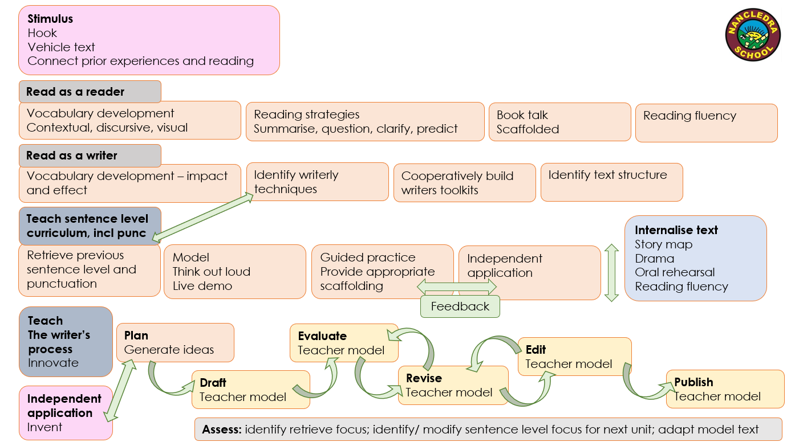

|  |  |  |  |  |  |  |  |
| --- | --- | --- | --- | --- | --- | --- | --- |
| **LKS2 Spelling** | **UKS2 Spelling** | | **Pupil Terminology** | | | | |
| * use further preﬁxes and sufﬁxes and understand how to   add them (English Appendix 1)   * spell further homophones * spell words that are often miss-pelt (English Appendix 1) * place the possessive apostrophe accurately in words with regular plurals [for example, girls’, boys’] and in words with irregular plurals [for example, children’s] * use the ﬁrst two or three letters of a word to check its   spelling in a dictionary  write from memory simple sentences, dictated by the teacher, that include words and punctuation taught so far. | * use further prefixes and suffixes and understand the guidance for adding them * spell some words with ‘silent’ letters [for example, knight, psalm, solemn] * continue to distinguish between homophones and other words which are often confused * use knowledge of morphology and etymology in spelling and understand that the spelling of some words needs to be learnt specifically, as listed in English Appendix 1 * use dictionaries to check the spelling and meaning of words * use the first three or four letters of a word to check spelling, meaning or both of these in a dictionary * use a thesaurus. | | **Year Two**  Noun  Noun phrase  Statement  Question  Exclamation  Command  Compound  Suffix  Adjective  Adverb  Verb  Tense (past, present)  Apostrophe  Comma | **Year Three**  Preposition  Conjunction  Word  Family  Prefix  Clause  subordinate clause  direct speech  consonant  consonant  letter  vowel  vowel  letter  inverted commas (or ‘speech marks’) | **Year Four**  determiner  pronoun,  possessive  pronoun  adverbial | **Year Five**  modal verb  relative pronoun relative clause parenthesis  bracket  dash  cohesion  ambiguity | **Year Six**  Subject  object  active  passive  synonym  antonym  ellipsis  hyphen  colon  semi-colon  bullet points |
| **LKS2 Composition** | | **UKS2 Composition** | | | | | |
| Plan their writing by:   * discussing writing similar to that which they are planning to write in order to understand and learn from its structure, vocabulary and grammar * discussing and recording ideas   Draft & write by:   * composing and rehearsing sentences orally (including dialogue), progressively building a varied and rich vocabulary and an increasing range of sentence structures (English Appendix 2) * organising paragraphs around a theme * in narratives, creating settings, characters and plot * in non-narrative material, using simple organisational devices [for example, headings and sub-headings]   Evaluate & edit by:   * assessing the effectiveness of their own and others’ writing and suggesting improvements * proposing changes to grammar and vocabulary to improve consistency, including the accurate use of pronouns in sentences * proof-read for spelling and punctuation errors * read aloud their own writing, to a group or the whole class, using appropriate intonation and controlling the tone and volume so that the meaning is clear. | | *Plan their writing by:*   * identifying the audience for and purpose of the writing, selecting the appropriate form and using other similar writing as models for their own * noting and developing initial ideas, drawing on reading and research where necessary * in writing narratives, considering how authors have developed characters and settings in what pupils have read, listened to or seen performed   *Draft and write by:*   * selecting appropriate grammar and vocabulary, understanding how such choices can change and enhance meaning * in narratives, describing settings, characters and atmosphere and integrating dialogue to convey character and advance the action * précising longer passages * using a wide range of devices to build cohesion within and across paragraphs * using further organisational and presentational devices to structure text and to guide the reader [for example, headings, bullet points, underlining]   *Evaluate and edit by:*   * assessing the effectiveness of their own and others’ writing * proposing changes to vocabulary, grammar and punctuation to enhance effects and clarify meaning * ensuring the consistent and correct use of tense throughout a piece of writing * ensuring correct subject and verb agreement when using singular and plural, distinguishing between the language of speech and writing and choosing the appropriate register * proof-read for spelling and punctuation errors * perform their own compositions, using appropriate intonation, volume, and movement so that meaning is clear. | | | | | |
| **LKS2 Grammar & Punctuation** | | | **UKS2 Grammar & Punctuation** | | | | |
| Develop their understanding of the concepts set out in English Appendix 2 by:   * extending the range of sentences with more than one clause by using a wider range of conjunctions, including when, if, because although * using the present perfect form of verbs in contrast to the past tense * choosing nouns or pronouns appropriately for clarity and cohesion and to avoid repetition * using conjunctions, adverbs and prepositions to express time and cause * using fronted adverbials * learning the grammar for years 3 and 4 in English Appendix 2   Indicate grammatical and other features by:   * using commas after fronted adverbials * indicating possession by using the possessive apostrophe with plural nouns * using and punctuating direct speech   use and understand the grammatical terminology in English Appendix 2 accurately and appropriately when discussing their writing and reading. | | | Develop their understanding of the concepts set out in English Appendix 2 by:   * recognising vocabulary and structures that are appropriate for formal speech and writing, including subjunctive forms * using passive verbs to affect the presentation of information in a sentence * using the perfect form of verbs to mark relationships of time and cause using expanded noun phrases to convey complicated information concisely * using modal verbs or adverbs to indicate degrees of possibility * using relative clauses beginning with who, which, where, when, whose, that or with an implied (i.e. omitted) relative pronoun * learning the grammar for years 5 and 6 in English Appendix 2   Indicate grammatical and other features by:   * using commas to clarify meaning or avoid ambiguity in writing * using hyphens to avoid ambiguity * using brackets, dashes or commas to indicate parenthesis * using semi-colons, colons or dashes to mark boundaries between independent clauses * using a colon to introduce a list * punctuating bullet points consistently   Use and understand the grammatical terminology in English Appendix 2 accurately and appropriately in discussing their writing and reading. | | | | |

**C4 2024-25**

|  |  |  |  |  |  |
| --- | --- | --- | --- | --- | --- |
| **YEAR 5** | | | **YEAR 6** | | |
| **Word** | | | **Word** | | |
| W5.1 |  | Converting nouns or adjectives into verbs using suffixes [for example, –ate; –ise; –ify | W6.1 |  | Use vocabulary to create informal speech |
| W5.2 |  | Verb prefixes [for example, dis–, de–, mis–, over– and re–] | W6.2 |  | Use vocabulary appropriate for formal speech and writing [for example, find out – discover; ask for – request; go in – enter] |
|  |  |  | W6.3 |  | How words are related by meaning as synonyms and antonyms [for example, big, large, little]. |
| **Sentence** | | | **Sentence** | | |
| S5.1 |  | Using relative clauses beginning with who, which, where, when, whose, that, or an omitted relative pronoun: embedded or at the end of a sentence. | S6.1 |  | Distinguish between active and passive voice; use passive to increase formality. |
|  |  | Indicate degrees of possibility with: | S6.2 |  | Identify and write non-standard English in direct speech for characterisation |
| S5.2 |  | adverbs [for example, perhaps, surely] | S6.3 |  | Identify and use dashes and ellipses in direct speech for characterisation |
| S5.3 |  | modal verbs [for example, might, should, will, must] | S6.4 |  | Use the subjunctive forms such as If I were or Were they to come in very formal writing and speech |
| S5.4 |  | Convert spoken word into direct speech (statement, question and exclamation) where the reporting clause is embedded | S6.5 |  | Identify and write a combination of sentence types to avoid repetition |
| S5.5 |  | Open, embed or end a paragraph with direct speech | S6.6 |  | Identify and write simple sentences to enhance the mood and/or add emphasis |
| S5.6 |  | Expand on direct speech with narrative to advance the plot |  |  |  |
| **Text** | | | **Text** | | |
| T5.1 |  | * Use conjunctive adverbs to open sentences and build cohesion within paragraphs: * to continue the same point (*additionally*,*moreover*) * to introduce examples (*for example*,*for instance*) * to show cause and effect (*consequently*,*as a result*) * to add emphasis (*in fact*, *certainly*) * to show a time relationship (*meanwhile*,*now*)   to organize a sequence or list (*next*, *finally*) | T6.1 |  | Linking ideas across paragraphs using a wider range of cohesive devices: repetition of a word or phrase, |
| T5.2 |  | Link ideas across paragraphs using tense choices [for example, he had seen her before] | T6.2 |  | * Use conjunctive adverbs to open sentences and build cohesion within paragraphs: * to show contradictions (*however*, *on the other hand*) |
| T5.3 |  | Identify and write personification | T6.3 |  | * Link ideas across paragraphs using ellipsis. |
| T5.4 |  | Identify and write similes | T6.4 |  | Identify and write cohesive paragraphs where the topic sentence links to the proceeding concluding sentence |
| T5.5 |  | Identify and write metaphor | T6.5 |  | Identify and write single sentence paragraphs to enhance the mood, add emphasis and/or alter the pace of the narrative |
| T5.6 |  | To link ideas across paragraphs use adverbials of time, place and/or number:   * show a time relationship (*meanwhile*,*now*)   organize a sequence or list (*next*, *finally*) | T6.6 |  | Layout devices [for example, headings, sub-headings, columns, bullets, or tables, to structure text] |
| **Punctuation** | | | **Punctuation** | | |
|  |  | Use parenthesis: |  |  | To mark the boundary between independent clauses [for example, It’s raining; I’m fed up] use: |
| P5.1 |  | Brackets | P6.1 |  | Semi-colon |
| P5.2 |  | Dashes | P6.2 |  | Colon |
| P5.3 |  | commas | P6.3 |  | Dash |
| P5.4 |  | Use commas to clarify meaning or avoid ambiguity | P6.4 |  | Use the colon to introduce a list |
| P5.5 |  | Identify and write ellipsis as a stop mark and an incomplete thought | P6.5 |  | Use semi-colons within lists |
| P5.6 |  | Identify and write ellipsis as a pause | P6.6 |  | Use bullet points to list information |
|  |  |  | P6.7 |  | Use hyphens to avoid ambiguity [for example, man eating shark versus man-eating shark, or recover versus re-cover] |
| **Terminology** | | | **Terminology** | | |
|  |  | Modal verb, relative pronoun relative clause parenthesis, bracket, dash cohesion, ambiguity |  |  | subject, object active, passive synonym, antonym ellipsis, hyphen, colon, semi-colon, bullet points |

|  |  |  |  |  |  |
| --- | --- | --- | --- | --- | --- |
| **Class Four Fiction Cycle B 2024-25** | | | | | |
| **AUT 1**  **Baghdad, Spatial Sense, Human Body** | **AUT2**  **French revolution, North America, classification of living things** | **SPR 1**  **The Rise of Hitler and World War II**  **South America, electricity** | **SPR 2**  **World War II and the Holocaust**  **Africa & Light** | **SUM**  **The cold War**  **British Geographical Issues**  **Reproduction** | **SUM 2**  **The History of Human Rights**  **Globalisation & Evolution** |
| **Hook:** film – ‘Tuesday’ by David Weisner  **Text:** Tales from Outer Suburbia  **Story Type:** short story  **Focus:** Describe settings and atmosphere  **Vocabulary:**  Undertow, sultry, bleary, bewilderment, recrimination, efficiency  **Toolkits:**  **Remember 1:** We can use capital letters and full stops to control our ideas.  **Remember 1:** We can use conjunctions to add more detail to our sentences.  **Toolkits** to describe setting and atmosphere effectively and succinctly in a short story  **Toolkit 1:** We can use expanded noun phrases to convey complicated information concisely  **Toolkit 2:** We can use semi-colons, **colons** or dashes to mark boundaries between independent clauses  **Writing curriculum objectives:**  S6.5, P6.1  **Remember objectives:**  P3.13, P4.1  **Writing process focus:**  Plan  **Publishing moment:**  Walk in Wednesday share | **Hook:**  **Text:**  **Story Type:**  **Focus:**  **Vocabulary:**  **Toolkits:**  **Remember 1:**  **Writing curriculum objectives:**  **Remember objectives:**  **Writing process focus:**  Draft & evaluate  **Publishing moment:** | **Hook:**  **Text:**  **Story Type:**  **Focus:**  **Vocabulary:**  **Toolkits:**  **Writing curriculum objectives:**  **Remember objectives:**  **Writing process focus:** | **Hook:**  **Text:**  **Story Type:**  **Focus:**  **Vocabulary:**  **Toolkits:**  **Writing curriculum objectives:**  **Remember objectives:**  **Writing process focus:** | **Hook:**  **Text:**  **Story Type:**  **Focus:**  **Vocabulary:**  **Toolkits:**  **Writing curriculum objectives:**  **Remember objectives:**  **Writing process focus:** | **Hook:**  **Text:**  **Story Type:**  **Focus:**  **Vocabulary:**  **Toolkits:**  **Sentence level curriculum objectives:**  **Remember objectives:**  **Writing process focus:** |

|  |  |  |  |  |  |
| --- | --- | --- | --- | --- | --- |
| **UKS2 Non-Fiction/ Poetry Cycle B 2024-25** | | | | | |
| **AUT 1**  **Baghdad, Spatial Sense, Human Body** | **AUT2**  **French revolution, North America, classification of living things** | **SPR 1**  **The Rise of Hitler and World War II**  **South America, electricity** | **SPR 2**  **World War II and the Holocaust**  **Africa & Light** | **SUM**  **The cold War**  **British Geographical Issues**  **Reproduction** | **SUM 2**  **The History of Human Rights**  **Globalisation & Evolution** |
| Poetry | **Text:**  **Invent**:  **Vocabulary:**  **Toolkits:**  **Writing curriculum objectives:**  **Remember objectives:**  **Writing process focus:**  **Publishing moment:** |  |  |  |  |