

**Nancledra’s Lower Key stage Two’s Writing Curriculum 2024-24**

Contents:

* Nancledra’s writing approach
* National Curriculum English Programme of Study: Year 2 and Lower Key Stage Two
* Nancledra’s Word, Sentence, Text and Punctuation curriculum and coverage
* Lower Key stage Two’s text and objective overview

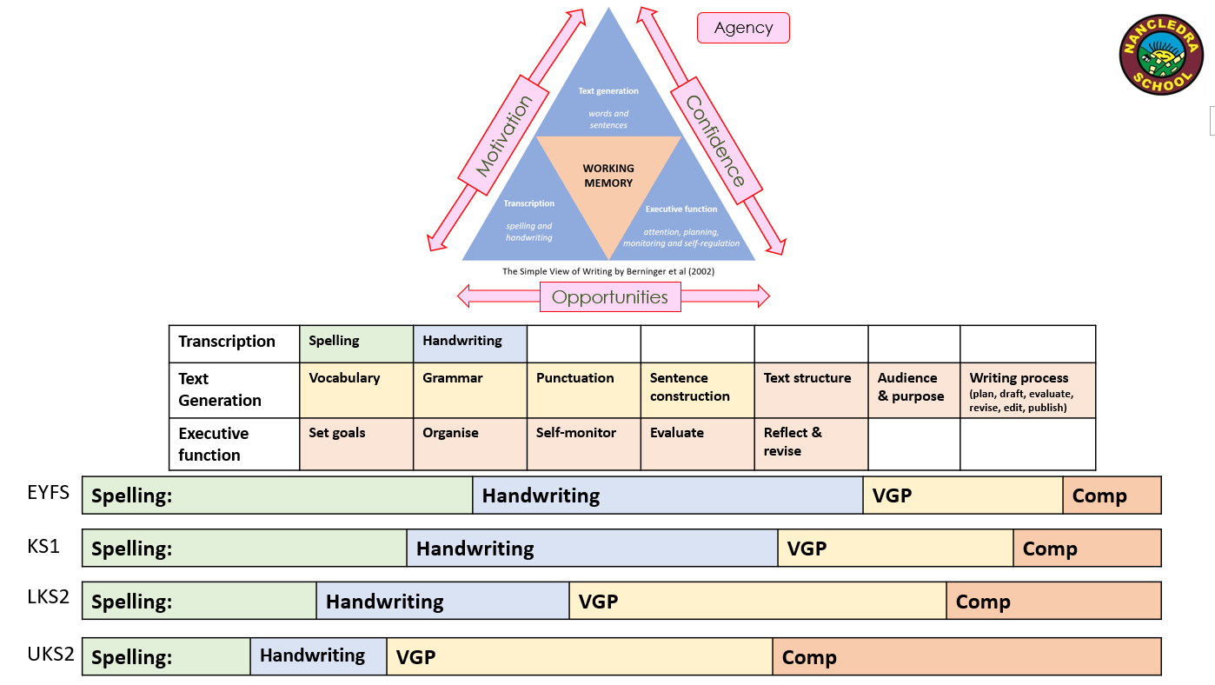Nancledra’s Writing Approach 2024-25

Nancledra’s Writing Approach 2024-25

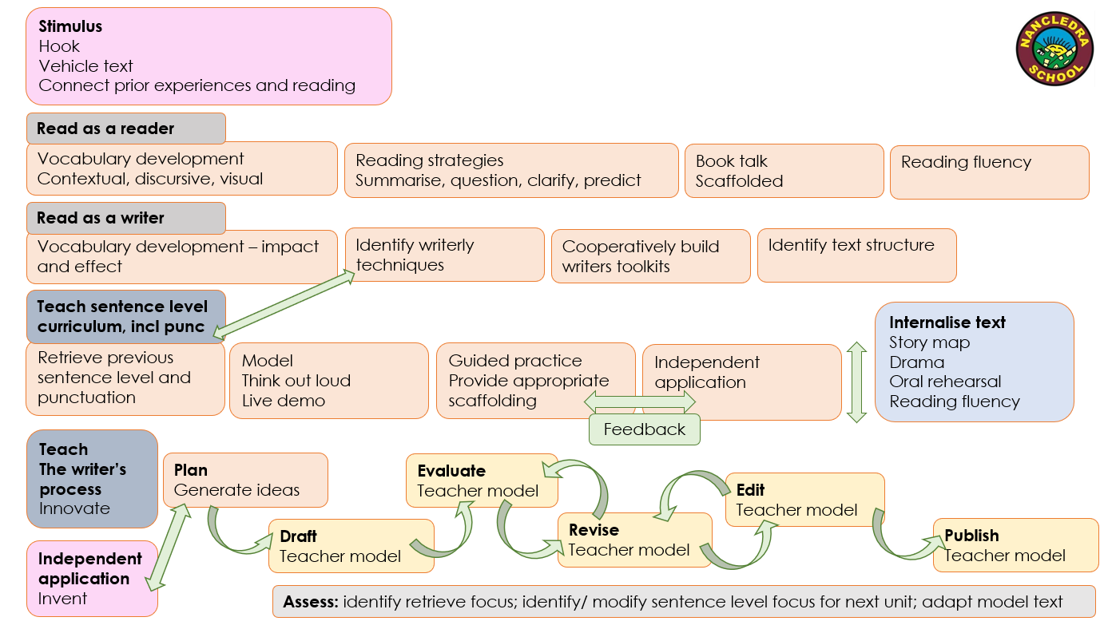

|  |  |  |  |  |  |  |
| --- | --- | --- | --- | --- | --- | --- |
| **Year Two Spelling** | **LKS2 Spelling** | | | **Pupil Terminology** | | |
| * segmenting spoken words into phonemes and representing these by graphemes, spelling many correctly * learning new ways of spelling phonemes for which one or more spellings are already known, and learn some words with each spelling, including a few common homophones * learning to spell common exception words * learning to spell more words with contracted forms * learning the possessive apostrophe (singular) [for example, the girl’s book] * distinguishing between homophones and near- homophones * add suffixes to spell longer words, including –ment,   –ness, –ful, –less, –ly   * apply spelling rules and guidance, as listed in English Appendix 1 * write from memory simple sentences dictated by the teacher that include words using the GPCs, common exception words and punctuation taught so far. | * use further preﬁxes and sufﬁxes and understand how to   add them (English Appendix 1)   * spell further homophones * spell words that are often miss-pelt (English Appendix 1) * place the possessive apostrophe accurately in words with regular plurals [for example, girls’, boys’] and in words with irregular plurals [for example, children’s] * use the ﬁrst two or three letters of a word to check its   spelling in a dictionary   * write from memory simple sentences, dictated by the teacher, that include words and punctuation taught so far. | | | **Year Two**  Noun  Noun phrase  Statement  Question  Exclamation  Command  Compound  Suffix  Adjective  Adverb  Verb  Tense (past, present)  Apostrophe  Comma | **Year Three**  Preposition  Conjunction  Word  Family  Prefix  Clause  subordinate clause  direct speech  consonant  consonant  letter  vowel  vowel  letter  inverted commas (or ‘speech marks’) | **Year Four**  determiner  pronoun,  possessive  pronoun  adverbial |
| **Year Two Composition** | | **LKS2 Composition** | | | | |
| Develop positive attitudes and stamina for writing by:   * writing narratives about personal experiences and those of others (real and fictional) * writing about real events * writing poetry * writing for different purposes * Consider what they are going to write before beginning by: * planning or saying out loud what they are going to write about * writing down ideas and/or key words, including new vocabulary * encapsulating what they want to say, sentence by sentence * Make simple additions, revisions and corrections to their own writing by: * evaluating their writing with the teacher and other pupils * re-reading to check that their writing makes sense and that verbs to indicate time are used correctly and consistently, including verbs in the continuous form * proof-reading to check for errors in spelling, grammar and punctuation [for example, ends of sentences punctuated correctly] * read aloud what they have written with appropriate intonation to make the meaning clear. | | Plan their writing by:   * discussing writing similar to that which they are planning to write in order to understand and learn from its structure, vocabulary and grammar * discussing and recording ideas   Draft & write by:   * composing and rehearsing sentences orally (including dialogue), progressively building a varied and rich vocabulary and an increasing range of sentence structures (English Appendix 2) * organising paragraphs around a theme * in narratives, creating settings, characters and plot * in non-narrative material, using simple organisational devices [for example, headings and sub-headings]   Evaluate & edit by:   * assessing the effectiveness of their own and others’ writing and suggesting improvements * proposing changes to grammar and vocabulary to improve consistency, including the accurate use of pronouns in sentences * proof-read for spelling and punctuation errors * read aloud their own writing, to a group or the whole class, using appropriate intonation and controlling the tone and volume so that the meaning is clear. | | | | |
| **Year Two Grammar & Punctuation** | | | **LKS2 Grammar & Punctuation** | | | |
| Develop their understanding of the concepts set out in English Appendix 2 by:   * learning how to use both familiar and new punctuation correctly (see English Appendix 2), including full stops, capital letters, exclamation marks, question marks, commas for lists and   Learn how to use:   * sentences with different forms: statement, question, exclamation, command * expanded noun phrases to describe and specify [for example, the blue butterfly] * the present and past tenses correctly and consistently including the progressive form * subordination (using when, if, that, or because) and co-ordination (using or, and, or but) * grammar for year 2 in English Appendix 2 * some features of written Standard English   use and understand the grammatical terminology in English Appendix 2 in discussing their writing. | | | Develop their understanding of the concepts set out in English Appendix 2 by:   * extending the range of sentences with more than one clause by using a wider range of conjunctions, including when, if, because although * using the present perfect form of verbs in contrast to the past tense * choosing nouns or pronouns appropriately for clarity and cohesion and to avoid repetition * using conjunctions, adverbs and prepositions to express time and cause * using fronted adverbials * learning the grammar for years 3 and 4 in English Appendix 2   Indicate grammatical and other features by:   * using commas after fronted adverbials * indicating possession by using the possessive apostrophe with plural nouns * using and punctuating direct speech * use and understand the grammatical terminology in English Appendix 2 accurately and appropriately when discussing their writing and reading. | | | |

**C3 2024-25 REMEMBER TAUGHT**

|  |  |  |  |  |  |
| --- | --- | --- | --- | --- | --- |
| **YEAR 1** | | | **YEAR 2** | | |
| **Word** | | | **Word** | | |
|  | W1.1 | Regular plural noun suffixes –s or –es [for example, dog, dogs; wish, wishes], including the effects of these suffixes on the meaning of the noun |  | W2.1 | Formation of nouns using suffixes such as –ness, –er and by compounding [for example, whiteboard, superman] |
|  | W1.2 | Suffixes that can be added to verbs where no change is needed in the spelling of root words (e.g. helping, helped, helper) |  | W2.2 | Formation of adjectives using suffixes such as –ful, –less |
|  | W1.3 | How the prefix un– changes the meaning of verbs and adjectives [negation, for example, unkind, or undoing: untie the boat] |  | W2.3 | Use of the suffixes –er, –est in adjectives and the use of –ly in Standard English to turn adjectives into adverbs |
| **Sentence** | | | **Sentence** | | |
|  | S1.1 | How words can combine to make sentences. | **AUT2** | S2.1 | Subordination conjunctions (using when, if, that, because) |
|  | S1.2 | Joining words and joining clauses using and | **AUT2** | S2.2 | Co-ordination conjunctions (using or, and, but) |
|  |  |  |  | S2.3 | Expanded noun phrases for description and specification [for example, the blue butterfly, plain flour, the man in the moon] |
|  |  |  |  |  | How the grammatical patterns in a sentence indicate its function as: |
|  |  |  |  | S2.4 | A statement |
|  |  |  |  | S2.5 | A question |
|  |  |  |  | S2.6 | An exclamation |
|  |  |  |  | S2.7 | A command |
| **Text** | | | **Text** | | |
|  | T1.1 | Sequencing sentences to form short narratives |  | T2.1 | Correct choice and consistent use of present tense and past tense throughout writing |
|  |  |  |  | T2.2 | Use of the progressive form of verbs in the present and past tense to mark actions in progress [for example, she is drumming, he was shouting] |
|  |  |  |  |  |  |
| **Punctuation** | | | **Punctuation** | | |
|  | P1.1 | Separation of words with spaces | **AUT1, AUT2** | P2.1 | Use of capital letters and full stops. |
|  | P.1.2 | Use a capital letter for names of people, places, the days of the week, and the personal pro-noun ‘I’. |  | P2.2 | Use of question marks |
|  |  | Introduction to: |  | P2.3 | Use of exclamation marks |
|  | P1.3 | Capital letters and full stops | **AUT1** | P2.4 | Commas to separate items in a list |
|  | P1.4 | Question marks |  | P2.5 | Apostrophes to mark where letters are missing in spelling |
|  | P1.5 | Exclamation marks |  | P2.6 | Apostrophes to mark singular possession in nouns [for example, the girl’s name] |
| **Terminology** | | | **Terminology** | | |
|  |  | letter, capital letter word, singular, plural sentence punctuation, full stop, question mark, exclamation mark |  |  | noun, noun phrase statement, question, exclamation, command compound, suffix adjective, adverb, verb tense (past, present) apostrophe, comma |

|  |  |  |  |  |  |
| --- | --- | --- | --- | --- | --- |
| **YEAR 3** | | | **YEAR 4** | | |
| **Word** | | | **Word** | | |
|  | W3.1 | Formation of **nouns** using a range of **prefixes** [for example *super–*, *anti–*, *auto–*] |  | W4.1 | The grammatical difference between **plural** and **possessive** *–s* |
|  | W3.2 | Use of the **forms** *a* or *an* according to whether the next **word** begins with a **consonant** or a **vowel** [for example, *a rock*, *an open box*] |  | W4.2 | Standard English forms for **verb** **inflections** instead of local spoken forms [for example, *we were* instead of *we was*,or *I did* instead of *I done*] |
|  | W3.3 | **Word families** based on common **words**, showing how words are related in form and meaning [for example, *solve, solution, solver, dissolve, insoluble*] |  |  |  |
| **Sentence** | | | **Sentence** | | |
| **AUT2** | S3.1 | Extend the range of sentences with more than one **clause** by using a wider range of **conjunctions**, e.g. when, if, because, although. | **AUT2** | S4.1 | Extend the range of sentences with more than one clause by using a wider range of **conjunctions**, e.g. when, if, because, although. |
|  |  | Expressing time, place and cause using: | **AUT1** | S4.2 | **Noun phrases** expanded by the addition of modifying adjectives, nouns and preposition phrases(e.g. *the teacher* expanded to: *the strict maths teacher with curly hair*) |
|  | S3.2 | **conjunctions** [for example, *when*, *before*, *after*, *while*, *so*, *because* |  | S4.3 | **Fronted** **adverbials** [for example, *Later that day*, *I heard the bad news.*] |
| **AUT1** | S3.3 | **adverbs** [for example, *then*, *next*, *soon*, *therefore*] |  |  |  |
| **AUT2NF** | S3.4 | **prepositions** [for example, *before*, *after*, *during*, *in*, *because of*] |  |  |  |
| **Text** | | | **Text** | | |
|  | T3.1 | Introduction to **paragraphs** as a way to group related material |  | T4.1 | Use of **paragraphs** to organise ideas around a theme |
| **AUT2NF** | T3.2 | Headings and sub-headings to aid presentation | **AUT2NF** | T4.2 | Appropriate choice of **pronoun** or **noun** within and across **sentences** to aid **cohesion** and avoid repetition |
|  | T3.3 | Use of the **present** **perfect** form of **verbs** instead of the simple past [for example, *He has gone out to play* contrasted with *He went out to play*] |  |  |  |
| **Punctuation** | | | **Punctuation** | | |
| **AUT2** | P3.1 | Introduction to inverted commas to **punctuate** direct speech:  *Use inverted commas around direct speech.*  *“We can run,” said Joe.* |  | P4.1 | Use of inverted commas and other **punctuation** to indicate direct speech [for example, a comma after the reporting clause; end punctuation within inverted commas: *The conductor shouted, “Sit down!”*]  *Not including paused speech:*  *“We can run!” said Joe.*  *Joe said, “We can run!”* |
|  |  |  |  | P4.2 | **Apostrophes** to mark **plural** possession [for example, *the girl’s name*, *the girls’ names*] |
|  |  |  |  | P4.3 | Use of commas after **fronted** **adverbials** |
| **Terminology** | | | **Terminology** | | |
|  |  | preposition, conjunction word family, prefix clause, subordinate clause direct speech  consonant, consonant letter vowel, vowel letter inverted commas (or ‘speech marks’) |  |  | determiner  pronoun,  possessive pronoun  adverbial |

|  |  |  |  |  |  |  |  |  |  |  |  |
| --- | --- | --- | --- | --- | --- | --- | --- | --- | --- | --- | --- |
| **Class Three Fiction Cycle B 2024-25** | | | | | | | | | | | |
| **AUT 1**  **Ancient Greece, Spatial Sense, Human Body** | | **AUT2**  **Ancient Greece, Mediterranean Europe, Classification of Plants & Animals** | | **SPR 1**  **Life in Ancient Rome, Eastern Europe, Ecology** | | **SPR 2**  **Rise and Fall of Rome, UK Geography – Ireland, Sound** | | **SUM**  **The Stuarts, UK Geography – London & The South-East, States of Matter and The Water Cycle** | | **SUM 2**  **The Stuarts, Asia – Japan, Electricity** | |
| **Hook:** Map to find a golden rope.  **Text:** Arthur & the Golden Rope  **Story Type:** Quest  **Focus:** Developing characters  **Vocabulary:**  Artefact, rarity, monstrous, triumphantly, solemnly, ferociously  **Toolkits:**  **Remember 1:** We can use capital letters and full stops to control our ideas.  **Remember 1:** We can use conjunctions to add more detail to our sentences.  **Toolkits** to develop characters which sound real and alive to the reader…  **Toolkit 1:** We can use expanded noun phrases to describe the characters.  **Toolkit 2:** We can use adverbs to tell the reader how a character does something.  **Writing curriculum objectives:**  S3.3, S4.2  **Remember objectives:**  P2.4  **Writing process focus:**  Plan  **Publishing moment:**  Walk in Wednesday share | | **Hook:** Screech Animal Sanctuary  **Text:** King of The Birds  **Story Type:** Wishing  **Focus:** Developing setting  **Vocabulary:**  **Toolkits:**  **Writing curriculum objectives:**  S3.1, S4.1, P3.1  **Remember objectives:**  S2.1, S2.2, P2.4  **Writing process focus:**  Draft & evaluate  **Publishing moment:** | | **Hook:**  **Text:**  **Story Type:**  **Focus:**  **Vocabulary:**  **Toolkits:**  **Writing curriculum objectives:**  **Remember objectives:**  **Writing process focus:** | | **Hook:**  **Text:**  **Story Type:**  **Focus:**  **Vocabulary:**  **Toolkits:**  **Writing curriculum objectives:**  **Remember objectives:**  **Writing process focus:** | | **Hook:**  **Text:**  **Story Type:**  **Focus:**  **Vocabulary:**  **Toolkits:**  **Writing curriculum objectives:**  **Remember objectives:**  **Writing process focus:** | | **Hook:**  **Text:**  **Story Type:**  **Focus:**  **Vocabulary:**  **Toolkits:**  **Sentence level curriculum objectives:**  **Remember objectives:**  **Writing process focus:** | |
| **LKS2 Non-Fiction/ Poetry Cycle B 2024-25** | | | | | | | | | | |
| **AUT 1**  **Ancient Greece, Spatial Sense, Human Body** | **AUT2**  **Ancient Greece, Mediterranean Europe, Classification of Plants & Animals** | | **SPR 1**  **Life in Ancient Rome, Eastern Europe, Ecology** | | **SPR 2**  **Rise and Fall of Rome, UK Geography – Ireland, Sound** | | **SUM**  **The Stuarts, UK Geography – London & The South-East, States of Matter and The Water Cycle** | | **SUM 2**  **The Stuarts, Asia – Japan, Electricity** | |
| Poetry | **Text:** Interview with a Tiger  Writing to inform and entertain.  **Invent**: Interview linked to Ancient Greece. E.g. interview with Alexander The Great, interview with Ancient Greece (The country)  **Vocabulary:**  **Toolkits:**  **Writing curriculum objectives:**  S3.4, T3.2, T4.2  **Remember objectives:**  **Writing process focus:**  Planning for non-fiction  **Publishing moment:** for class library and/ or send to Author Andy Seed | |  | |  | |  | |  | |