

**Nancledra’s Key Stage One’s Writing Curriculum 2024-24**

Contents:

* Nancledra’s writing approach
* National Curriculum English Programme of Study: Year 1 and Year 2
* Nancledra’s Word, Sentence, Text and Punctuation curriculum and coverage
* Key Stage One’s text and objective overview

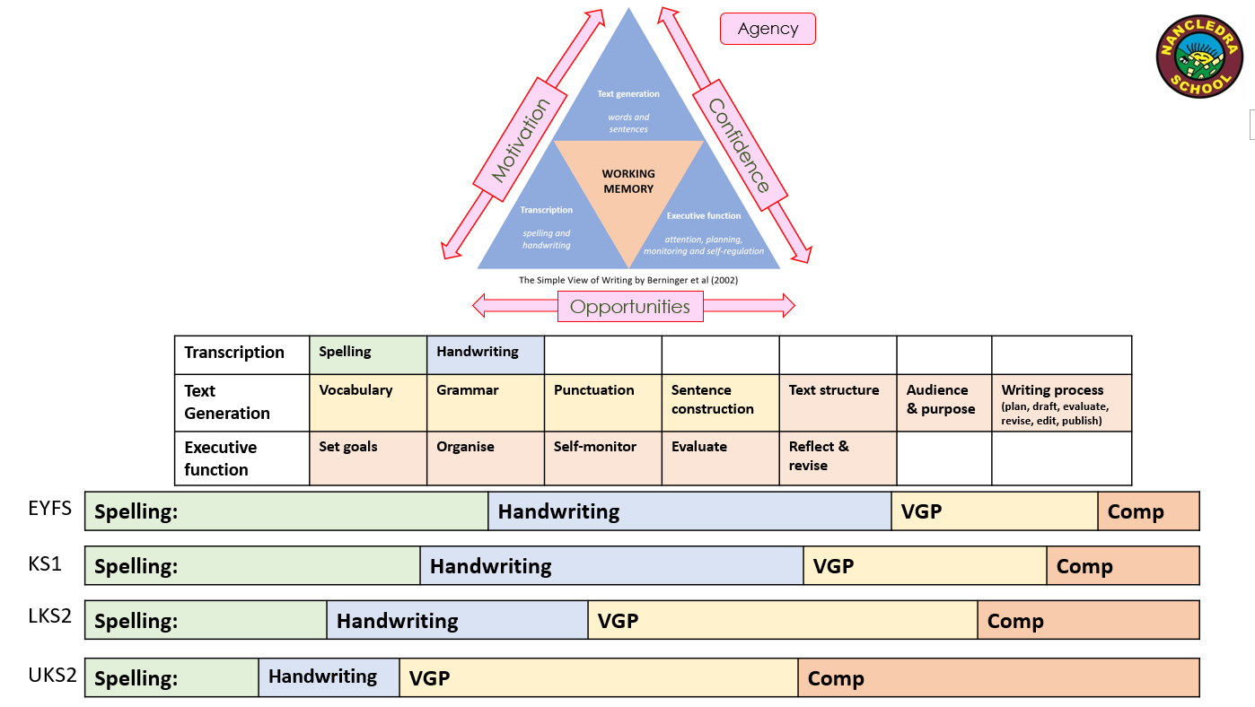Nancledra’s Writing Approach 2024-25

Nancledra’s Writing Approach 2024-25

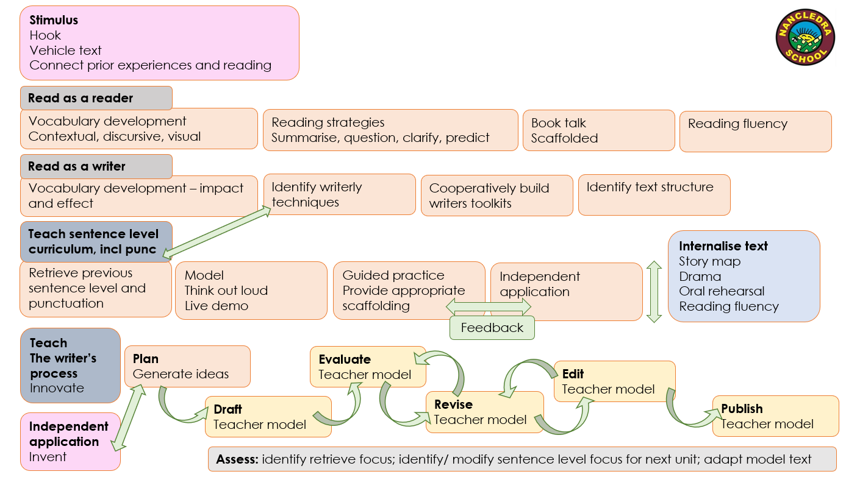

|  |  |  |  |  |  |
| --- | --- | --- | --- | --- | --- |
| **Year One Spelling** | **Year Two Spelling** | | **Year One Composition** | | |
| • words containing each of the 40+ phonemes already taught  • common exception words  • the days of the week  Add prefixes and suffixes:  • using the spelling rule for adding –s or –es as the plural marker for nouns and the third person singular marker for verbs • using the prefix un–  • using –ing, –ed, –er and –est where no change is needed in the spelling of root words [for example, helping, helped, helper, eating, quicker, quickest]  • apply simple spelling rules and guidance, as listed in English Appendix 1 • write from memory simple sentences dictated by the teacher that include words using the GPCs and common exception words taught so far | * segmenting spoken words into phonemes and representing these by graphemes, spelling many correctly * learning new ways of spelling phonemes for which one or more spellings are already known, and learn some words with each spelling, including a few common homophones * learning to spell common exception words * learning to spell more words with contracted forms * learning the possessive apostrophe (singular) [for example, the girl’s book] * distinguishing between homophones and near- homophones * add suffixes to spell longer words, including –ment,   –ness, –ful, –less, –ly   * apply spelling rules and guidance, as listed in English Appendix 1 * write from memory simple sentences dictated by the teacher that include words using the GPCs, common exception words and punctuation taught so far. | | Write sentences by:   * saying out loud what they are going to write about * composing a sentence orally before writing it * sequencing sentences to form short narratives * re-reading what they have written to check that it makes sense * discuss what they have written with the teacher or other pupils * read aloud their writing clearly enough to be heard by their peers and the teacher. | | |
| **Year Two Composition** | | |
| Develop positive attitudes and stamina for writing by:   * writing narratives about personal experiences and those of others (real and fictional) * writing about real events * writing poetry * writing for different purposes * Consider what they are going to write before beginning by: * planning or saying out loud what they are going to write about * writing down ideas and/or key words, including new vocabulary * encapsulating what they want to say, sentence by sentence * Make simple additions, revisions and corrections to their own writing by: * evaluating their writing with the teacher and other pupils * re-reading to check that their writing makes sense and that verbs to indicate time are used correctly and consistently, including verbs in the continuous form * proof-reading to check for errors in spelling, grammar and punctuation [for example, ends of sentences punctuated correctly] * read aloud what they have written with appropriate intonation to make the meaning clear. | | |
| **Year One Grammar & Punctuation** | | **Year Two Grammar & Punctuation** | | **Terminology for pupils** | |
| Develop their understanding of the concepts set out in English Appendix 2 by:   * leaving spaces between words * joining words and joining clauses using and * beginning to punctuate sentences using a capital letter and a full stop, question mark or exclamation mark * using a capital letter for names of people, places, the days of the week, and the personal pronoun ‘I’ * learning the grammar for year 1 in English Appendix 2 * use the grammatical terminology in English Appendix 2 in discussing their writing. | | Develop their understanding of the concepts set out in English Appendix 2 by:   * learning how to use both familiar and new punctuation correctly (see English Appendix 2), including full stops, capital letters, exclamation marks, question marks, commas for lists and apostrophes for contracted forms and the possessive (singular)   Learn how to use:   * sentences with different forms: statement, question, exclamation, command * expanded noun phrases to describe and specify [for example, the blue butterfly] * the present and past tenses correctly and consistently including the progressive form * subordination (using when, if, that, or because and co-ordination (using or, and, or but) * grammar for year 2 in English Appendix 2 * some features of written Standard English * use and understand the grammatical terminology in English Appendix 2 in discussing their writing. | | **Year One**  Letter  Capital  Word  Singular  Plural  Sentence  Punctuation  Full stop  Question mark  Exclamation mark | **Year Two**  Noun  Noun phrase  Statement  Question  Exclamation  Command  Compound  Suffix  Adjective  Adverb  Verb  Tense (past, present)  Apostrophe  Comma |

**C2 2024-25 TAUGHT**

|  |  |  |  |  |  |
| --- | --- | --- | --- | --- | --- |
| **YEAR 1** | | | **YEAR 2** | | |
| **Word** | | | **Word** | | |
|  | W1.1 | Regular plural noun suffixes –s or –es [for example, dog, dogs; wish, wishes], including the effects of these suffixes on the meaning of the noun |  | W2.1 | Formation of nouns using suffixes such as –ness, –er and by compounding [for example, whiteboard, superman] |
|  | W1.2 | Suffixes that can be added to verbs where no change is needed in the spelling of root words (e.g. helping, helped, helper) |  | W2.2 | Formation of adjectives using suffixes such as –ful, –less |
|  | W1.3 | How the prefix un– changes the meaning of verbs and adjectives [negation, for example, unkind, or undoing: untie the boat] |  | W2.3 | Use of the suffixes –er, –est in adjectives and the use of –ly in Standard English to turn adjectives into adverbs |
| **Sentence** | | | **Sentence** | | |
| **AUT1** | S1.1 | How words can combine to make sentences. | **SPR2** | S2.1 | Subordination conjunctions (using when, if, that, because) |
| **AUT1** | S1.2 | Joining words and joining clauses using and | **AUT1** | S2.2 | Co-ordination conjunctions (using or, and, but) |
|  |  |  | **AUT1** | S2.3 | Expanded noun phrases for description and specification [for example, the blue butterfly, plain flour, the man in the moon] |
|  |  |  |  |  | How the grammatical patterns in a sentence indicate its function as: |
|  |  |  | **AUT2** | S2.4 | A statement |
|  |  |  | **AUT1** | S2.5 | A question |
|  |  |  | **AUT2** | S2.6 | An exclamation |
|  |  |  |  | S2.7 | A command |
| **Text** | | | **Text** | | |
|  | T1.1 | Sequencing sentences to form short narratives | **SPR2** | T2.1 | Correct choice and consistent use of present tense and past tense throughout writing |
|  |  |  |  | T2.2 | Use of the progressive form of verbs in the present and past tense to mark actions in progress [for example, she is drumming, he was shouting] |
|  |  |  |  |  |  |
| **Punctuation** | | | **Punctuation** | | |
| **AUT1** | P1.1 | Separation of words with spaces | **AUT1** | P2.1 | Use of capital letters and full stops. |
| **SPR1** | P.1.2 | Use a capital letter for names of people, places, the days of the week, and the personal pro-noun ‘I’. | **AUT1** | P2.2 | Use of question marks |
|  |  | Introduction to: | **AUT2** | P2.3 | Use of exclamation marks |
| **AUT1** | P1.3 | Capital letters and full stops | **SPR2** | P2.4 | Commas to separate items in a list |
| **AUT1** | P1.4 | Question marks | **SPR2** | P2.5 | Apostrophes to mark where letters are missing in spelling |
| **AUT2** | P1.5 | Exclamation marks | **SPR1** | P2.6 | Apostrophes to mark singular possession in nouns [for example, the girl’s name] |
| **Terminology** | | | **Terminology** | | |
|  |  | letter, capital letter word, singular, plural sentence punctuation, full stop, question mark, exclamation mark |  |  | noun, noun phrase statement, question, exclamation, command compound, suffix adjective, adverb, verb tense (past, present) apostrophe, comma |

|  |  |  |  |  |  |
| --- | --- | --- | --- | --- | --- |
| **KS1 Fiction Cycle B 2024-25** | | | | | |
| **AUT 1**  **Spatial Sense & the Human Body** | **AUT2**  **Romans** | **SPR 1**  **British isles** | **SPR 2**  **Tudors** | **SUM**  **Northern Europe** | **SUM 2**  **Powerful Voices** |
| **Hook:** Find a lost penguin  **Story Type**: Finding Tale  **Focus**: Description, setting  **Innovation:** Girl finds a lion cub and takes it back to Africa (can keep the boat).  **Toolkits:**   * I can use coordinating conjunctions to add more detail to the reader’s imagination. * To bring settings alive we can use adjectives to describe them (noun phrases)   **Writing curriculum objectives:**  S1.1, S1.2, S2.2, S2.3 S2.5  P1.1, P1.3, P1.4, P2.1, P2.2  **Remember objectives:**  ELG: write correctly formed letters  **Writing process focus:**  Plan  **Publishing moment:** | **Hook:**  **Text:** Three Little Pigs  **Story Type**: Defeating the monster  **Focus**: Traditional tale  **Innovation:** Change the pigs to any other animal and the materials to other materials e.g. Or innovate who is writing it. E.g. from the wolf’s perspective.  **Toolkits:**   * **To bring settings alive we can use adjectives to describe them (noun phrases)**   **Writing curriculum objectives:**  S2.4, S2.6, P1.5, P2.3  **Remember objectives:**  ELG: write correctly formed letters  S1.1, S1.2, S2.2  P1.1, P1.3, P2.1  **Writing process focus:**  Draft & evaluate  **Publishing moment:** | **Hook:**  **Text:** George and The Dragon  **Story Type**: Defeating The Monster  **Focus**:  **Innovation:**  **Toolkits:**   * **I can use coordinating conjunctions to add more detail to the reader’s imagination.** * I can use subordinating conjunctions (if, because) to add reasons and consequences to my sentences.   **Writing curriculum objectives:**  S2.1, P2.6, P1.2  **Remember objectives:**  S1.1, S.1.2, S2.2  P1.1, P1.3, P2.1  **Writing process focus:**  Evaluate & edit  **Publishing moment:** | **Hook:**  **Text:** The Tiger Who Came To Tea  **Story Type**: Meeting  **Focus**: Characterisation through actions e.g. rushed  **Innovation:** A different animal comes to tea or a fairy tale character.  **Toolkits:**   * We can show how a character is feeling and not just tell the reader.(Vocabulary choices - verbs) * We can use the correct tense to help our reader know when the story took place.   **Writing curriculum objectives:**  P2.4, P2.5, S2.1, T2.1  **Remember objectives:**  S1.1, S.1.2, S2.2  P1.1, P1.3, P2.1  **Writing process focus:**  Evaluate and revise (vocabulary focus)  **Publishing moment:** | **Hook:**  **Text: T**he Papaya that spoke  **Story Type**: journey  **Focus**:  **Innovation:** A girl lives in a bustling city and goes to the library where many of the objects talk.  **Toolkits:**  All **remember** toolkits, see below.   * **I can use coordinating conjunctions to add more detail to the reader’s imagination.** * **I can use subordinating conjunctions (if, because) to add reasons and consequences to my sentences.**   **Writing curriculum objectives:**  **Remember objectives:**  S1.1, S.1.2, S2.2, S2.1  P1.1, P1.2, P1.3, P2.1, P2.5  **Writing process focus:**  All | **Hook:**  **Text:** The Lighthouse Keeper’s Lunch  **Story Type**: Defeating The Monster  **Focus:** imagery through adjectives for description  **Innovation:** The Pirate’s Breakfast (use Captain Flinn and the Pirate dinosaurs as inspiration)  **Toolkits:**  All **remember** toolkits, see below.   * **I can use coordinating conjunctions to create a clearer picture for our reader.** * **I can use subordinating conjunctions (if, because) to add reasons and consequences to my sentences.** * **We can use the correct tense to help our reader know when the story took place.** * **To bring settings alive we can use adjectives to describe them (noun phrases)**   **Writing level curriculum objectives:**  **Remember objectives:**  S1.1, S.1.2, S2.2, S2.1  P1.1, P1.2, P1.3, P2.1, P.2.3, P2.5  **Writing process focus**: All |

|  |  |  |  |  |  |
| --- | --- | --- | --- | --- | --- |
| **KS1 Non-Fiction Cycle B 2024-25** | | | | | |
| **AUT 1**  **Spatial Sense & the Human Body** | **AUT 1**  **Spatial Sense & the Human Body** | **AUT 1**  **Spatial Sense & the Human Body** | **AUT 1**  **Spatial Sense & the Human Body** | **AUT 1**  **Spatial Sense & the Human Body** | **AUT 1**  **Spatial Sense & the Human Body** |
| **NF Text:** Diary of penguin  **NF Genre:** Recount  **Innovation:** Diary of the night gardener. (CH can invent from a character from their supporting texts in AUT1 & AUT2)  **Toolkits:**   * I let the reader know what order the events happened in by using time adverbs. * I can use the conjunction ‘because’ to explain my ideas and thoughts. * I can use coordinating conjunctions to connect ideas and events together.   **Punc;** CL and fullstops and question marks | **NF Text:** Big Bad Wolf NCR  **NF Genre:** NCR  **Innovation:** Tiger from the Tiger who came to teaor a fairy tale pet.  **Toolkits:**   * We can use technical vocabulary to make us sound like experts. E.g prey and canines * To help the reader read lists of nouns or adjectives we can separate them with commas.   **Punc;** Apostrophes for contraction. | **NF Text:** How to trap a dragon  **NF Genre:** Instructions  **Innovation:** How to trap a wolf (link back to wolf from three little pigs) or from the witches perspective of how to catch children from the witches perspective  **Toolkits:**   * Use bossy verbs to make actions clear * Vary sentence starters to keep the reader interested * Use adverbs to make it really clear how to do something.   **Punc; CL and fullstops** | **NF Text:** Should The Tiger be sent to jail?  **NF Genre:** Discussion  **Innovations:** Should the witch from Hansel and Gretel be jailed? (Allows CH to use: Should the wolf be jailed in their invention)  **Toolkits:**   * We number our reasons to help our reader follow our opinion clearly * We use the conjunction ‘when’ to make our evidence clear and detailed. (Subordinating conjunctions)   **Punc;** Commas in a list  **Remember: Cl proper nouns and use and to join sentences.** | **NF Text:** Join Our Super Vegetable Crew  **NF Genre:** Persuasion (poster)  **Innovation:** Join Our Wicked Crew!  *Invent could be Join Our powerful Crew, Kind Crew, Fairytale Crew, Good Guy Crew, Superhero Crew*  **Toolkits:**   * Use rhetorical questions to encourage the reader to listen. * **I can use coordinating conjunctions to connect ideas and events together.** * I can use commands to tell my reader what to do. **(Linked to bossy verbs from SPR1)**   **Punc; Remember: Question marks, exclamation marks.** | **NF Text:** Why Are Seagulls a Nuisance?  **NF Genre:** Explanation  **Innovation:** Why are dolphins so friendly? (Dolphin Boy inspiration) OR Use a villain from a fairy take – Why Are Trolls so Greedy?  **Toolkits:**   * I can use generalisers to let the reader know how often or how many. * I can use subordinating conjunctions in different parts of the sentence to emphasise information. * I can choose my words precisely and carefully to ensure my reader gets a clear picture of my explanation.   **Punc;**  **commas between 2 adjectives**  **exclamation marks**  **CL and fullstops** |