Class One’s AUT Writing Curriculum: Stick Man, Emma-Jane’s Aeroplane, The Gruffalo

Dictation sequence:
1: SAY (Say the sentence children repeat back x3.)
2: COUNT (Word Count - use fingers. CT then children)
3: BUILD (from left to right the pre-written words)
4: REPEAT (say accurate sentence together)
5: WRITE (CT hide the sentence built, and model writing same sentence)
6: Check (Every Time We Write)
7: Children Write

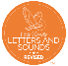
Phonics knowledge: s a t p i n m d g o c k ck e u r h b f l
Tricky words: is I the
Date | Text | Vocabulary | Letter formation | Dictation: sentence/ phrase | Outcome
WC 4th Nov | Talk Through Stories  Stick Man  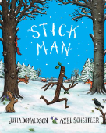 | Word 1: twirl (twirling, twirled)  Word 2: tumbling (tumble, tumbled)  Word 3: shove (shoves, shoved)  Word 4: weary  Word 5: chuckle (chuckled, chuckling) Word 6: doze (dozed, dozing)  Word 7: clattering (clatter, clattered)  Word 8: drifts (drifting, drifted) | Introducing long ladder letters: l,i,t,u,j,y  Practising long ladder letters: l,i  Practising long ladder letters: t,u  Practising long ladder letters: j,y  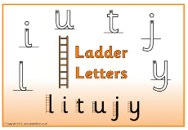 | Wk 1:  Stick Man  the dog  Santa | WK1: Label characters
WC 11th Nov |  |  |  | Wk 2:  I am stick man  I can jog  I can hop | WK2: Write a speech bubble for stick man

WC 18th Nov | Talk Through Stories  Emma Jane’s Aeroplane  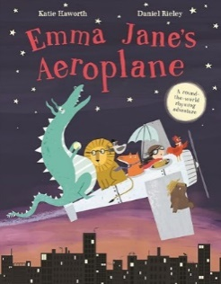 | swoops, shakes, prance, stormy, churning, zooms | Introducing curly caterpillar letters:  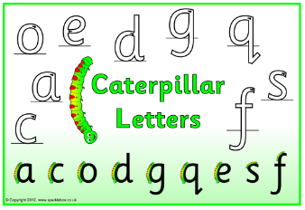 | WK1:  Write a label for their chosen animal.  cat, pig, dog, hen, fox, duck, frog | WK1:  Choosing their own animal to go in the plane. Images needed of the possible animals they could spell with known sounds:  cat, pig, dog, hen, fox, duck, frog
WC 25th Nov |  |  |  | WK 2:  William is in the aeroplane.  Word in bold is written for them.  Change child’s name as appropriate. | Draw a picture of them in the aeroplane and write their sentence with their name. Provide the word aeroplane for them and they fill in the rest.

WC 2nd Dec | Talk For Writing  The Gruffalo  Julia Donaldson  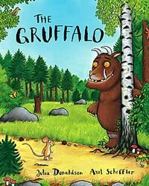 | Stroll, underground,  terrible, roasted, sped. | Introducing capital letters:  Children to practice writing  their single letters both  uppercase and lowercase.  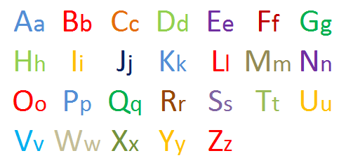 | Immersion  Hook: Footprints and a letter…  Lesson 1:  Read story, create story map and explore the characters. | Immersion  Lesson 2:  Retell using story map, create a picture of the Gruffalo using the same colours.
WC 9th Dec |  | Poisonous, flew, feast, prickles, scrambled. |  | Imitation  Lesson 1:  Shared short-burst write. Model sentence writing  “I can hear _____ in the bushes ahead.”  Collecting animal sounds from the children. | Imitation  Lesson 2:  Circle time- animals noises and what animals like to eat. Who’s in the bag? What do they eat?  Role play groups acting the story.
WC 16th Dec |  | Creature, bursting, ahead, fled. |  | Innovation  Lesson 1:  Retell with the story map.  Build a sentence, hold a sentence, write a sentence. | Innovation  Lesson 2:  Build a sentence, hold a sentence, write a sentence.
Innovation sentence ideas:
I can see a _______ on the path ahead.

Draw a picture of a path in the woods. Who can you see on the path ahead?
Write the sentence once, then write it again.

Extension (Lesson 2)
Label other things in the picture… twig, grass, rock…

